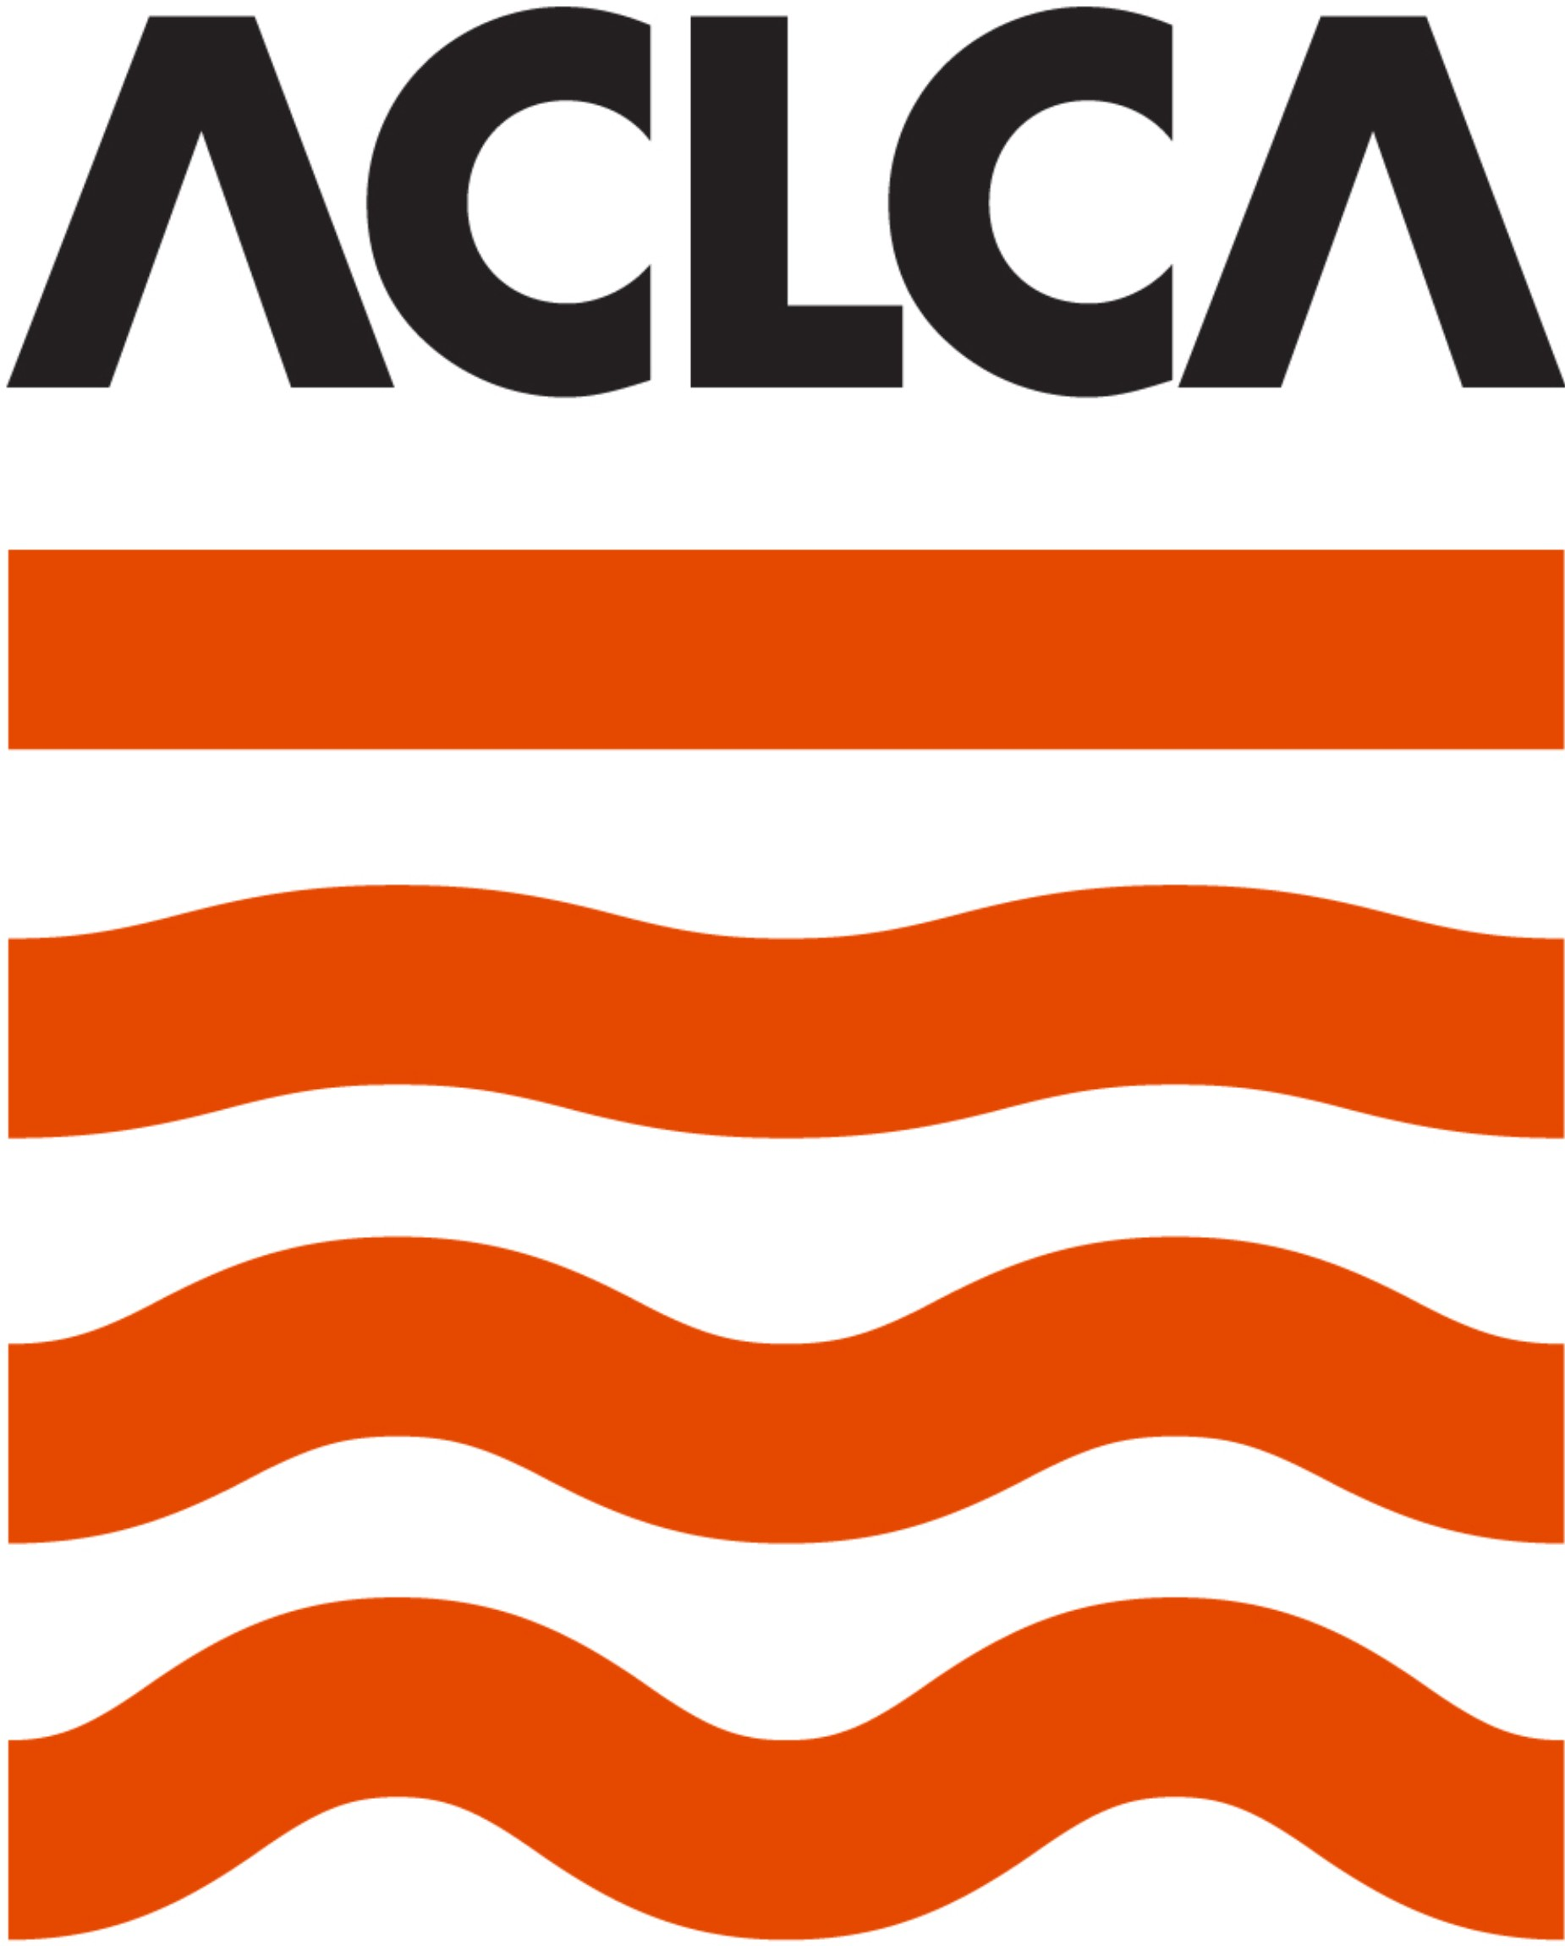

Australian Contaminated Land Consultants Association (NSW) Inc.
ABN: 36533132904

MEMBERSHIP APPLICATION FORM

Eligibility
ACLCA NSW membership is open to businesses which can demonstrate that their primary business is consulting to external clients; and business activities include either:
  - A practice in land contamination management by a single employee who is either a NSW EPA-Accredited Site Auditor or a suitably qualified practitioner who is certified as a specialist in site contamination under a NSW EPA-endorsed certification scheme; or
  - A substantial practice in land contamination management, with specialist environmental staff employed to perform full-time in the area of land contamination management.
Acceptance is subject to the ACLCA NSW Membership Sub-Committee’s final consideration and decision. The Sub-Committee’s decision is final.

Is your primary business consulting to external clients?
Yes No

Does your business support a full-time practice in land contamination management?
Yes No

If you answered Yes to both questions proceed to Q2.
If you answered No to either question, unfortunately your business is not eligible for membership to ACLCA NSW.

Acceptance of ACLCA NSW Code of Practice
Membership of ACLCA NSW is only open to businesses willing to accept and abide by our Code of Practice.
Is your business willing to accept the ACLCA NSW Code of Practice and attach signed copy (signed by an authorised Company representative) with this application?
Yes (copy attached) No

Has your business implemented an Ethical Standards Policy and attached a signed copy (signed by an authorised Company representative) of that policy with this application?
Yes (copy attached) No

If you answered Yes to both questions (and attached documentation) proceed to Q3.
If you answered No to either question, unfortunately your business is not eligible for membership to ACLCA NSW.

Applicant Details
Applicants must complete the following details for the ACLCA NSW membership register:

Name of Business:
ABN Number:
Name & title of Appointed Contact:
Sole Practitioner Applicants: | Site Auditor Accreditation No. :
Certification Scheme:
Certification No. :
Company (Contact) Address:
Phone number(s):
Email address:
How many full-time equivalent staff members do you have working in contaminated land practice in NSW?

Membership Selection Criteria
Documentation (as listed below) is required to be provided with your application to support the following selection criteria:
- Professional Competency/Qualifications;
- Quality Management System (QMS); and
- Management of Contaminated Land Projects.

Your membership application will be assessed on the merit of the documentation you provide with this application. Single employee applicants (i.e. Site Auditors and Certified Practitioners) should provide a detailed description of how quality is maintained in their individual practices.

Professional Competency/Qualifications
Can your business demonstrate professional competency and appropriate qualifications in contaminated land management? This shall include:
- recognised and relevant engineering, scientific or technical qualifications;
- appropriate experience/competency for statement of duties;
- in-house/external training in all relevant techniques for collection of samples/ monitoring, occupational health and safety training;
- familiarity with basic concepts, policy and legislation issues relating to contaminated land.

To support this application the applicant is requested to provide copies of the following documents: (please tick those provided)
Business organisation chart List of relevant personnel
Curriculum vitae for relevant personnel Position descriptions for relevant personnel Training register and/or training certificates Industry memberships /affiliations

Quality Management System (QMS)
Can your business demonstrate implementation of an appropriate QMS for controlling quality/adequacy of consultancy services? It is expected that the QMS would:
  - be appropriate for the size and structure of the organisation;
  - be appropriate to the nature of the work undertaken;
  - include internal audit procedure;
  - be an independently accredited QMS (not mandatory).

To support this application the applicant is requested to provide copies of the following documents: (please tick those provided)
Quality policy

The Table of Contents from the applicant’s current Quality Manual Certificate of accreditation (as applicable)
Other (please specify)

Management of Contaminated Land Projects
Can your business demonstrate appropriate work practices and standards on sample project(s)?

To support this application the applicant is requested to provide the following documents: (please tick those provided)
Sample project final report (generic, if preferred) Environmental management plan (generic, if preferred) Health and Safety plan (generic, if preferred)
Sampling and analysis plan (generic, if preferred)
Other (please specify)

Examples should include consideration of a comprehensive range of potential environmental issues (including soil and groundwater).

If a sample project final report cannot be provided for such a project, then a comprehensive generic example should be provided. Client details and site details need not be provided, and all submissions will be treated as confidential.

Declaration
Has your company been the subject of any disciplinary action by NSW EPA or other regulatory authorities during the last year? If so please provide details.
Yes No

Annual Fees
Annual membership fees for ACLCA NSW are calculated on the number of staff your business has working in the area of contaminated land consulting, as below.

No. of Staff * | Annual Fee
Single-employee CLM practice  (Site Auditor or Certified practitioner **) | $330
5 staff or less | $990
6 - 15 staff | $1,990
16 -25 staff | $2,990
25 staff or more | $3,490
* Full-time equivalent working in CLM practice, ** Site Contamination specialist

If your application is approved, you will be asked to make payment of annual membership fee by EFT or credit card.

Overview of the Application Review Process
The assessment of applications is undertaken broadly as follows:
The ACLCA NSW Membership Sub-Committee considers the membership application in the first instance.
A system of scoring is applied in considering the application with respect to membership criteria:

- Conformance with Code of Practice;
- Ethical Standards;
- Professional Competency/Qualifications;
- Quality Management System (QMS); and
- Management of Contaminated Land Projects.

If the Membership Sub-Committee identifies any issue with the application, or considers that further information is required, the applicant will be informed in writing, which may include a request to provide further information / examples and possibly a meeting with the Membership Sub-Committee. The applicant will be invited to provide a timeline for addressing any application issues.
The application, including outcomes from addressing any application issues, are then provided by the Membership Sub-Committee to the ACLCA NSW Executive Committee, together with the Membership Sub-Committee’s recommendations. The Committee then votes on whether the application meets membership requirements.
If the application is successful, the Committee requests the applicant to provide full payment of joining and annual membership fees and confirms membership upon receipt of full payment.
If the application is not successful, the Committee provides the applicant with a list of non-conformance items and invites the applicant to resubmit the application. If that application is also unsuccessful, no further application can be submitted by the applicant until the next membership year.

We will inform you of the review decision as soon as possible, however, please be advised that this process can take some months to complete, as the Membership Sub-Committee meets to review applications every 2-3 months. Please don’t hesitate to contact me if you have any queries.

Regards,
Prue Kohlrusch Executive Officer For and on behalf of ACLCA (NSW) Inc Tel: 0432-60402
nsw@aclca.com.au
